|  |  |  |  |  |  |  |  |
| --- | --- | --- | --- | --- | --- | --- | --- |
| logoarenalsprings-01   |  | | --- | | **Arenal Springs Resort & Spa** | | | | | | | |
| **Arenal Vimai, S.A.** | | | | | | |
| **T - 2479 1212 Ext 1911 F - 2479 1818** | | | | | | |
| [**compras@hotelarenalsprings.com**](mailto:compras@hotelarenalsprings.com) | | | | | | |
| **www. hotelarenalsprings.com** | | | | | | |
| Músico | | | | | | |
| **Cód.** | **Nombre Proveedor** | **T.** | **Fec.** | **M** | **Monto** | **#Factura** |
| 899 | BENAVIDES HERNANDEZ JOSUE | D | 13/05/15 | $ | 900.00 | 308 |
| 899 | BENAVIDES HERNANDEZ JOSUE | D | 13/05/15 | $ | 900.00 | 308. |
| 899 | BENAVIDES HERNANDEZ JOSUE | D | 04/08/15 | $ | 350.00 | 334 |
| 899 | BENAVIDES HERNANDEZ JOSUE | D | 14/02/16 | $ | 250.00 | 437 |
| 899 | BENAVIDES HERNANDEZ JOSUE | D | 07/12/16 | $ | 400.00 | 705 |
| 899 | BENAVIDES HERNANDEZ JOSUE | D | 01/01/17 | $ | 3,200.00 | 732 |
| 899 | BENAVIDES HERNANDEZ JOSUE | D | 01/06/17 | $ | 700.00 | 899 |
| 899 | BENAVIDES HERNANDEZ JOSUE | D | 01/07/17 | $ | 800.00 | 938 |
| 899 | BENAVIDES HERNANDEZ JOSUE | D | 29/08/17 | $ | 800.00 | 1009 |
| 899 | BENAVIDES HERNANDEZ JOSUE | D | 01/09/17 | $ | 900.00 | 964 |
| 899 | BENAVIDES HERNANDEZ JOSUE | D | 14/11/17 | $ | 700.00 | 1092 |
| 899 | BENAVIDES HERNANDEZ JOSUE | D | 14/11/17 | $ | 800.00 | 1050 |
| 899 | BENAVIDES HERNANDEZ JOSUE | D | 01/12/17 | $ | 600.00 | 1172 |
| 899 | BENAVIDES HERNANDEZ JOSUE | D | 01/12/17 | $ | 400.00 | 1135 |
| 899 | BENAVIDES HERNANDEZ JOSUE | D | 21/12/17 | C | 150,000.00 | 1199 |
| 899 | BENAVIDES HERNANDEZ JOSUE | D | 24/12/17 | $ | 3,900.00 | 1222 |
| 899 | BENAVIDES HERNANDEZ JOSUE | D | 01/02/18 | $ | 400.00 | 1254 |
| 899 | BENAVIDES HERNANDEZ JOSUE | D | 01/02/18 | $ | 400.00 | 1292 |

El Hotel Arenal Springs Resort & Spa invita a instituciones de la comunidad que vengan al hotel hacer actividades que ellos desarrollan como lo es bailes típicos y músicos como lo ve en el histórico al lado derecho.

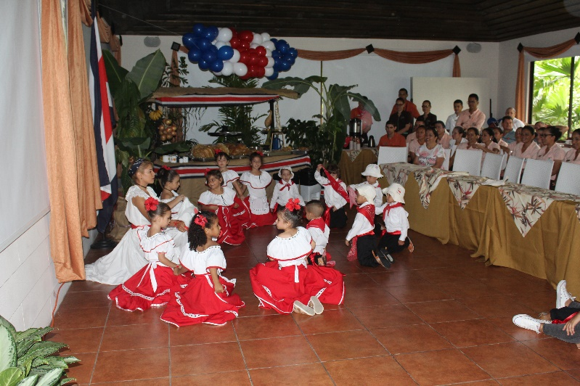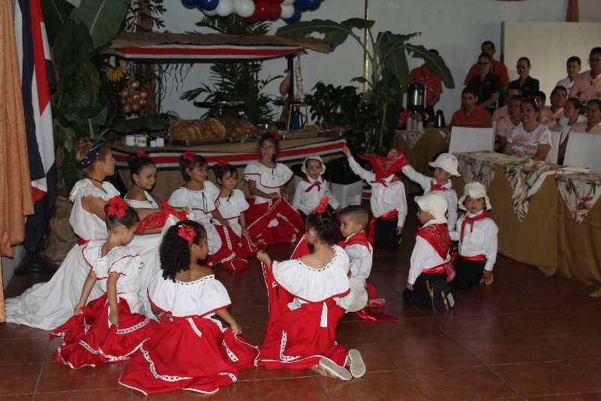

Jardín de Niños Ángel Gabriel