**Tree Planting Program**

**Arenal Springs Resort & Spa**

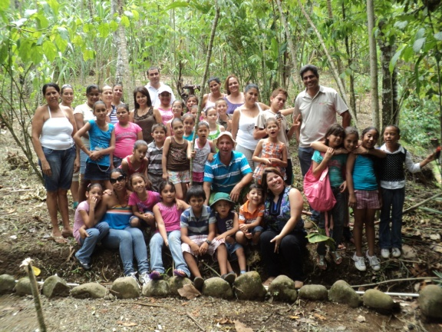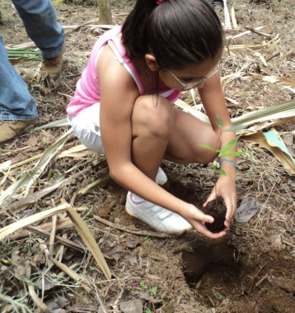Arenal Springs Resort & Spa is aware of the current environmental problems. One of the greatest factors influencing this situation is the worldwide deforestation, which continues at an alarming rate of about 13 million hectares per year. The loss of natural forests worldwide is the greatest annual contributor to global emissions, rather than the transportation as is commonly thought.  Curbing deforestation is a highly cost efficient in reducing emissions.  
One of the priorities of Arenal Springs Resort & Spa is the awareness of the serious effects of climate change on society, through programs and campaigns of reforestation and tree planting, which are aimed towards educational institutions.  
This process is performed in conjunction with the company Arenal Natura, which seeks to raise awareness in children and teenagers on the importance of trees in their environment for soil protection, habitat for flora and fauna, oxygen purification, etc. so they have a deeper understanding of  how important it is to care for and plant trees. They get a tour of park facilities to learn to appreciate amphibians and reptiles of this country and late plant a tree to inspire them to continue the reforestation project in the future.  
Arenal Springs Resort & Spa is committed to providing the proper maintenance of the reforested area; all the planted trees are native to the area so they do not affect the environmental balance of the area.  
In reception area, you can observe a sign for our "Adopt a Tree” program. For the sum of $10, we representatively place a flag of the country of origin of the donor in space poster, this money is given to Ecocentro Danaus Company and will be used to purchase land around the reserve to create a biological corridor for wildlife.